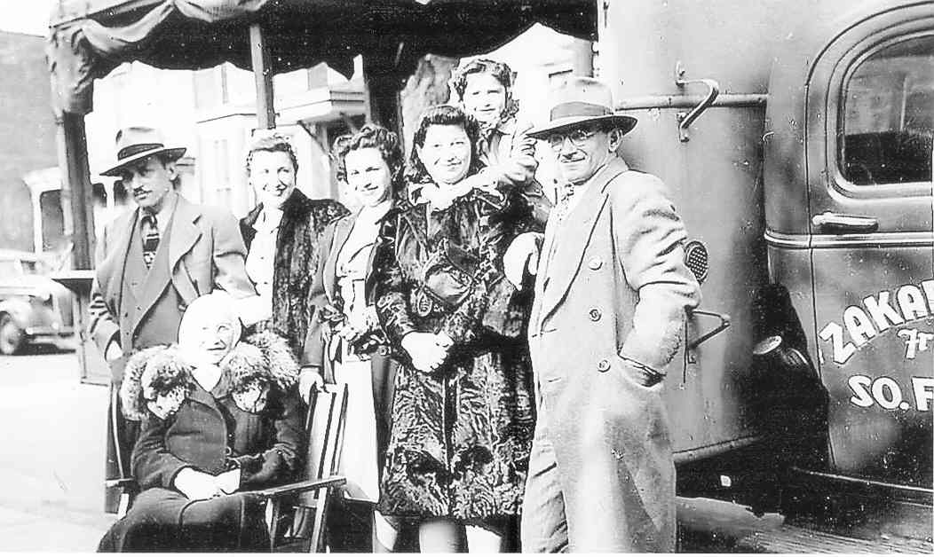
Zakarins with Isidor's truck used to transport fruit and vegetables to market – circa 1942

From left to right: Harry Zakarin, Esther Zakarin (seated), Molly Feldberg, Belle Feldberg, Marcia Zakarin (Abe Zakarin's wife), Rena Zakarin, and Isidor Zakarin

Photo Courtesy of Ronald Zakarin

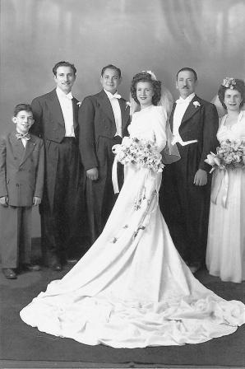
From the wedding of Eli and Molly Feldberg Klukoffsky – circa 1944
From left to right: Ben Feldberg, Murray Feldberg, Eli and Molly Feldberg Klukoffsky, Isidore Feldberg, Belle Feldberg

Photo Courtesy of Murray Feldberg
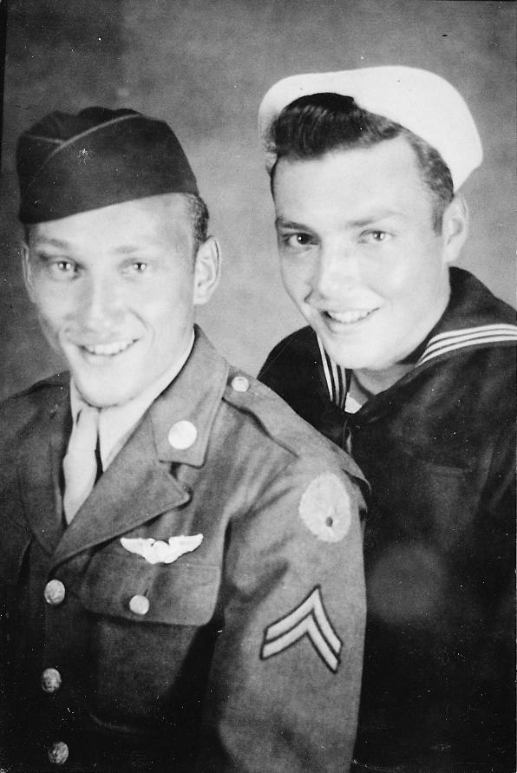
Irving and Davey Zakarin in the U.S. Armed Forces – circa 1946
From left to right: Irving Zakarin (Harry's son) - Air Corps,
Davey Zakarin – U.S. Navy

Photo Courtesy of Hunter Zupnick

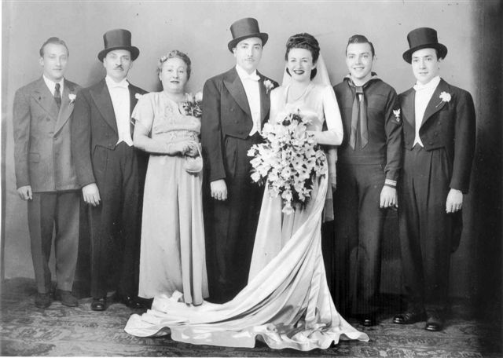
From the wedding of Leo & Pearl Zakarin – 1946

From left to right: Irving Zakarin (Harry's son), Harry Zakarin, Anna Zakarin, Leo Zakarin, Pearl Zakarin, Davey Zakarin, Victor Zakarin

Photo Courtesy of Eric Zakarin
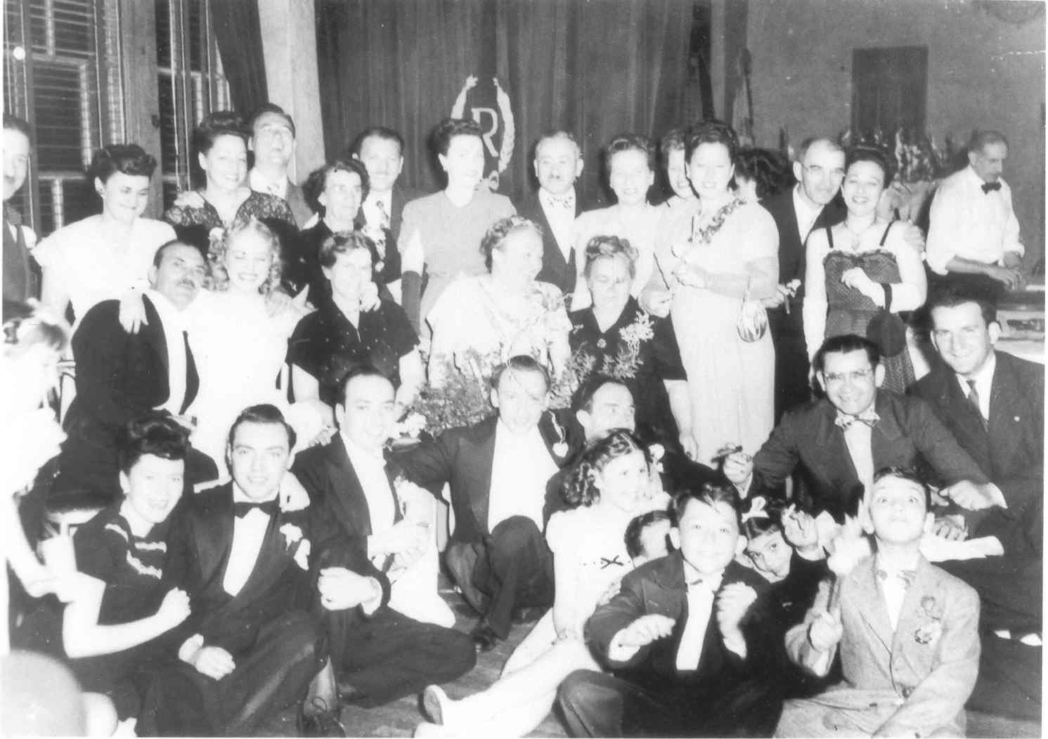
Zakarin family photo from the wedding of Rhoda & Victor Zakarin – 1949

Top Row: Isadore Feldberg, Olga Zakarin Garelick, Rose Cohen Raskin & Bernard Raskin, Ida Zakarin Cohen, Nat Raskin & Lena Cohen Raskin, Jack & Evelyn Kriveloff, Minna Zakarin (Lou Zakarin's wife), Mollie Zakarin (Alex Zakarin's wife), Isidor Zakarin, Estelle Zakarin (Sam "Sholom" Zakarin's wife)
Second Row: Harry Zakarin, Rhoda Zakarin (Victor Zakarin's wife), Annie Zakarin (Isidor Zakarin's wife), Anna Zakarin (Harry Zakarin's wife), Ida Voronoff Zakarin (Kalman Zakarin's wife), Sam "Sholom" Zakarin, Jack Zakarin
Front Row: Rhoda Kriveloff, Davey Zakarin, Victor Zakarin, Irving Zakarin (Harry Zakarin's son), Alex Zakarin, Sharon Brenda Zakarin, Abe Zakarin (part of forehead visible in front of Brenda Zakarin), Melvin Zakarin, Barbara Zakarin, Leonard Zakarin.

Photo Courtesy of Murray Feldberg

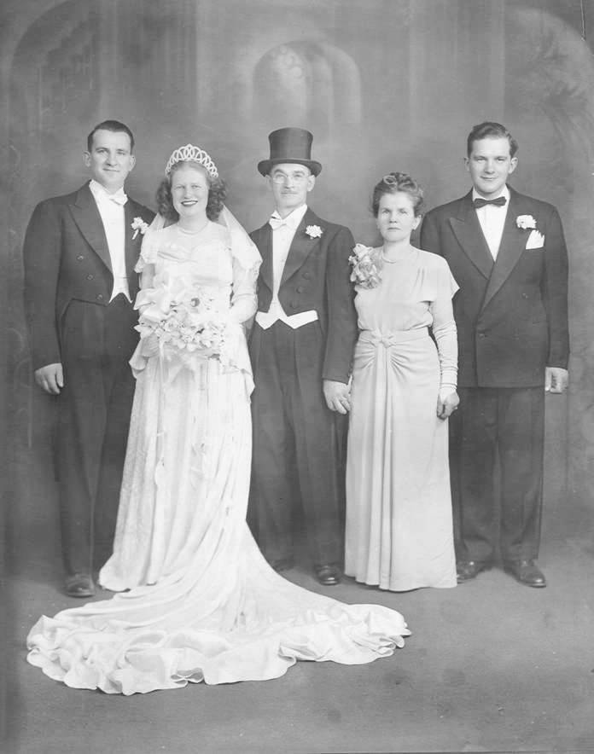
From the wedding of Jack & Anita Zakarin – circa 1949

From left to right: Jack Zakarin, Anita Zakarin, Isidor Zakarin, Annie Zakarin, Samuel Lester Zakarin

Photo Courtesy of Murray Feldberg

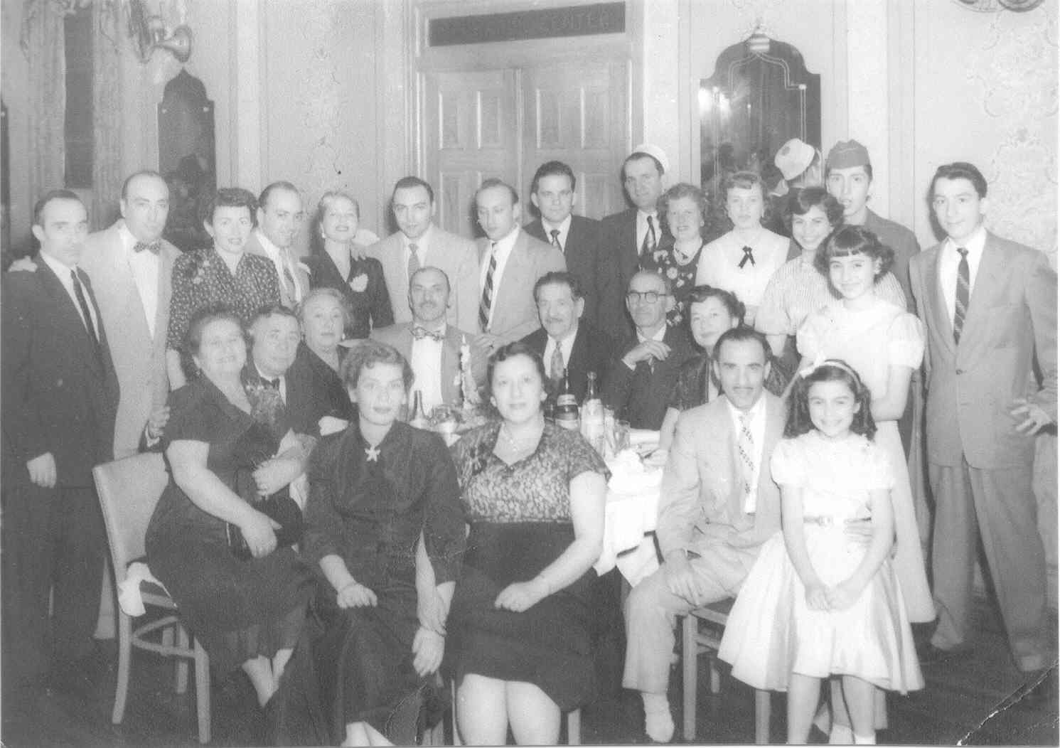
Zakarin family circa 1954
Back row standing from left to right: Alex Zakarin, Leo & Pearl Zakarin, Victor & Rhoda Zakarin, Davey Zakarin, Irving Zakarin, Samuel Lester Zakarin, Jack & Anita Zakarin, Marilyn Zakarin, Barbara Zakarin, Leonard Zakarin (in uniform), Rena Zakarin (in front of Barbara and Leonard), Melvin Zakarin
Seated behind table from left to right: Ms. Werthleib (Anna Zakarin's sister), Mr. Werthleib, Anna & Harry Zakarin, Isadore Feldberg, Isidor Zakarin, Marcia Zakarin (Abe Zakarin's wife)
Seated in front of table from left to right: Iris Zakarin (Lester Zakarin's wife), Mollie Zakarin (Alex Zakarin's wife), Abe Zakarin, Sheila Zakarin

Photo Courtesy of Murray Feldberg

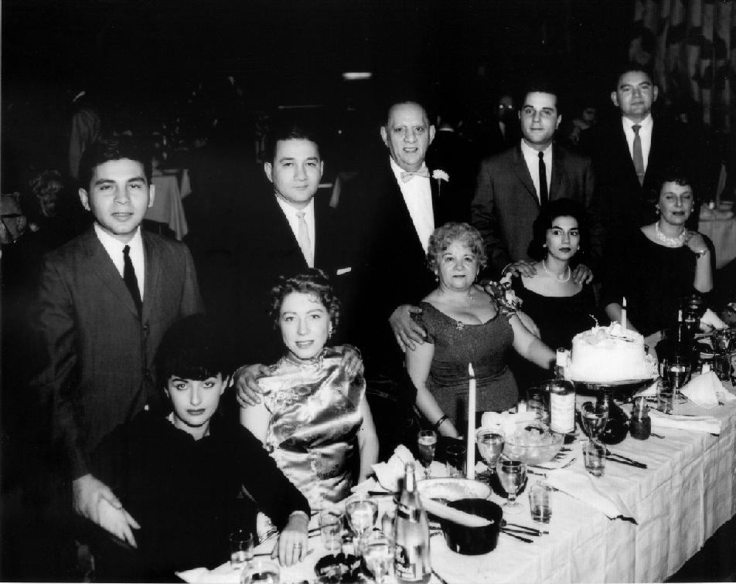 Charlie & Sally (Sarah) Zakarin and family circa 1955
Couples from left to right: Norman and Phyliss Zakarin, Mort and Evelyn Zakarin, Charlie and Sally (Sarah) Zakarin, Irwin and Sharon Zakarin Margulies, Irving and Miriam Zakarin

Photo Courtesy of Evelyn & Mort Zakarin

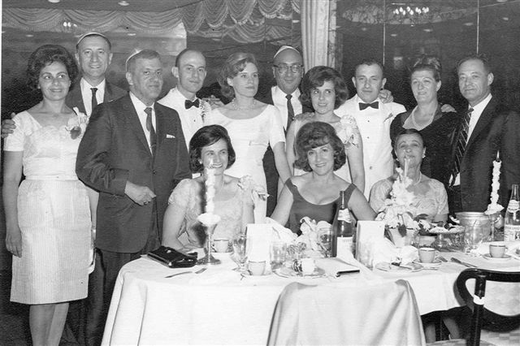
From the wedding of Ben and Janet Feldberg - 1965
Back Row: Trudy & Murray Feldberg, Manny Hecht, Ben & Janet Feldberg, Leo Zakarin, Roz & Sam Feldberg, Elaine Katzeff, Hyman Kruglack
Seated Front Row: Belle Feldberg Hecht, Mollie Feldberg Klukoffsky, Celia Kruglack

Photo Courtesy of Murray Feldberg

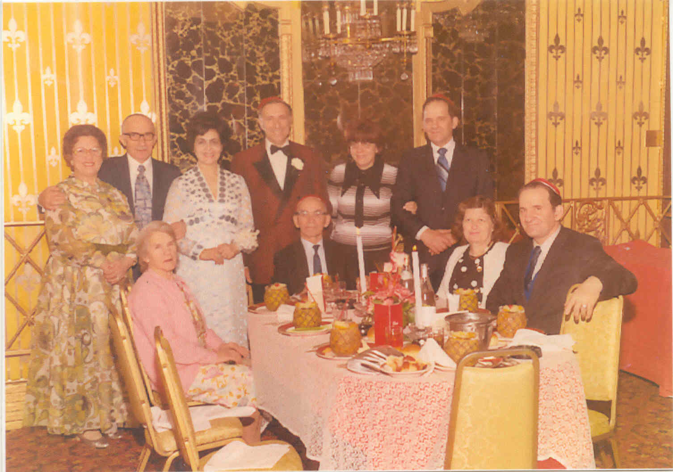
From Robert Feldberg's Bar Mitzvah Celebration – circa 1972
Back Row: Mollie & Alex Zakarin, Trudy & Murray Feldberg, Shirley & Samuel Lester Zakarin
Seated Front Row: Annie & Isidor Zakarin, Anita & Jack Zakarin

Photo Courtesy of Murray Feldberg

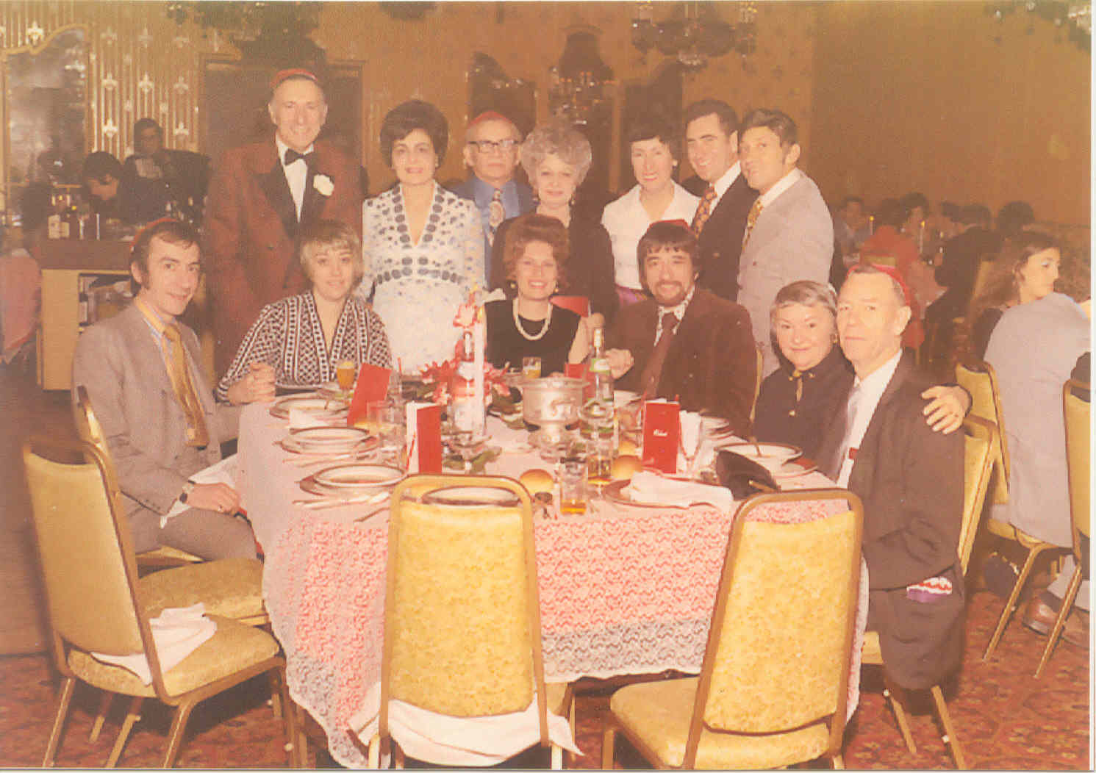
From Robert Feldberg's Bar Mitzvah Celebration – circa 1972
Back Row: Murray & Trudy Feldberg, Sam "Sholom" & Estelle Zakarin, unidentified woman, Joe Kriveloff, Irving Zakarin (Harry Zakarin's son)
Seated Front Row: Melvin & Marcia Zakarin, Iris & Lester Zakarin, Rose & Jess Sellers

Photo Courtesy of Murray Feldberg

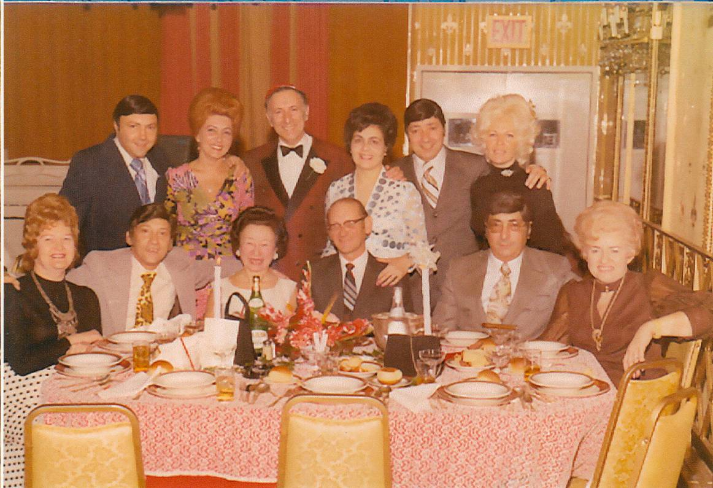
From Robert Feldberg's Bar Mitzvah Celebration – circa 1972
Back Row: Davey & Estelle Zakarin, Murray & Trudy Feldberg, Victor & Rhoda Zakarin
Seated Front Row: Annette and Irving Zakarin, Mary & George Getzlek (family friends), Leo & Pearl Zakarin

Photo Courtesy of Murray Feldberg
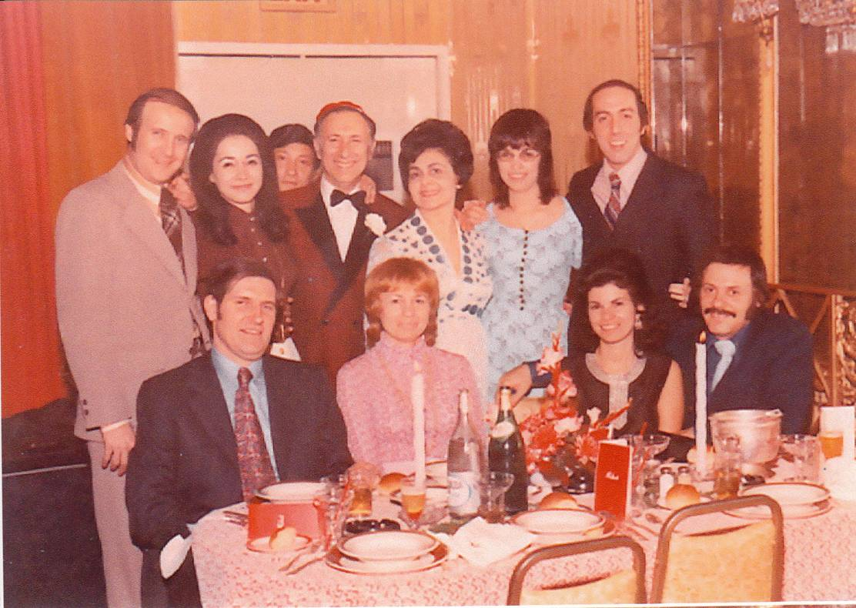 From Robert Feldberg's Bar Mitzvah Celebration – circa 1972
Back Row: Alan and Rena Zakarin Goldenberg, Irving Zakarin (Harry's son), Murray and Trudy Feldberg, Sheila Zakarin Berman and Bruce Shapiro
Seated Front Row: Walter and Marilyn Zakarin Belous, Barbara Zakarin and Erwin Klugerman

Photo Courtesy of Murray Feldberg

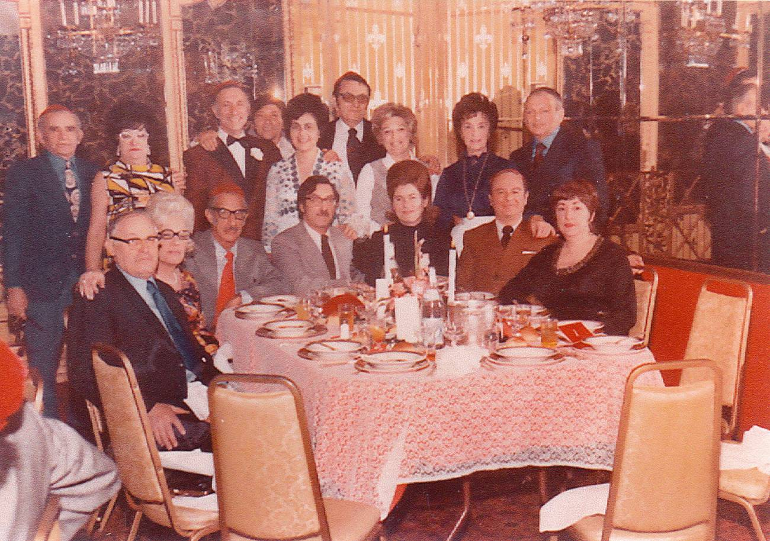

From Robert Feldberg's Bar Mitzvah Celebration – circa 1972
Back Row: Sam "Sholom" Zakarin, Gertie Cohen, Murray Feldberg, Irving Zakarin (Harry's son), Trudy Feldberg, Nat & Lena Cohen Raskin, Mrs. & Mr. Friedman (family friends)
Seated Front Row: Morris and Mollie Strouchler, Sidney Cohen, Ralph & Claire Cohen, Bernard & Rose Cohen Raskin

Photo Courtesy of Murray Feldberg

