Montefiore Cemetery – Elders

Photos: Chuck Zakarin

Montefiore Cemetery
121-83 Springfield Blvd.
Springfield Gardens, New York
718-528-1700

Name | Society | Block | Row | Grave
Samuel Zakarin | Chevra Mishnaias of East New York
Esther Zakarin | Chevra Mishnaias of East New York | 18 | 2L | 3

Translations of the Hebrew inscriptions are provided.

Notes:

(1) All inscriptions end with the ubiquitous Hebrew acronym:
"May his/her spirit be bound in the bond of life."

(2) The symbol using the Hebrew letter:
Is a title - usually pronounced as "Reb" or "Rabi" - which was commonly added to a man's name as a sign of respect, and should not be confused with the title, "Rabbi."
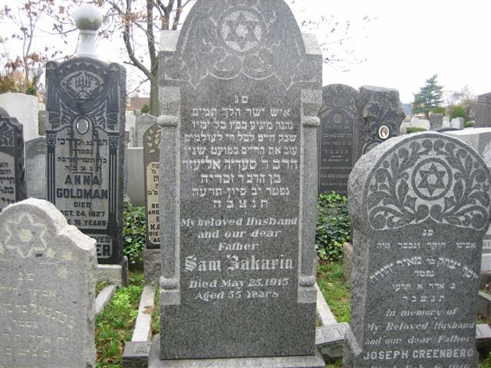

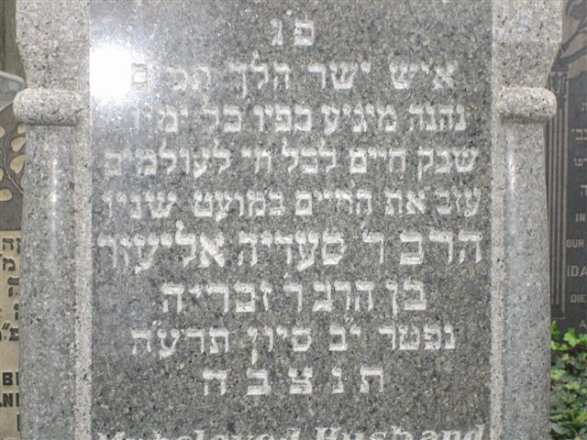

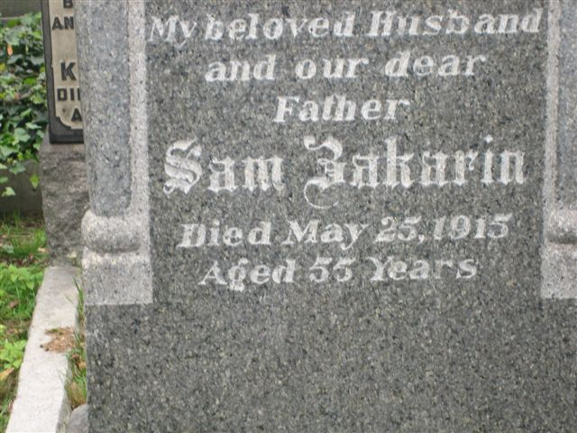
Gravestone of Samuel Zakarin
Hebrew inscription:
"Here is buried an honest and upright man
Who enjoyed the fruits of his labor all his life
Who departed from life while still in his youth
The Rabbi Reb Saadya Eliezer, son of the Rabbi Reb Zacharia
Died on the 12th day of the month of Sivan, year 5675."

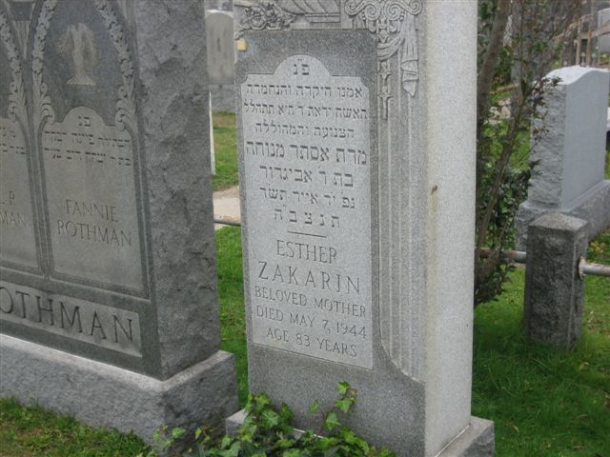

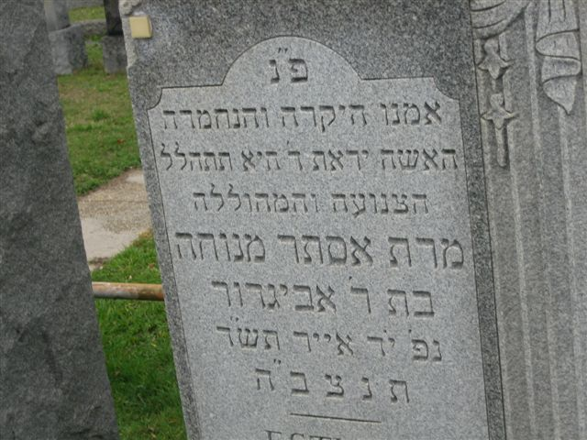

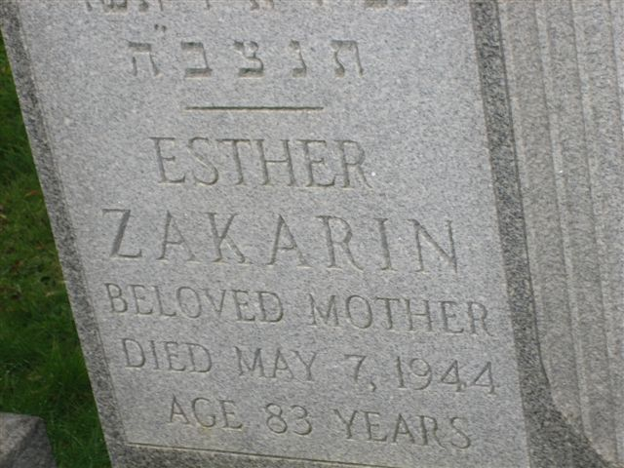
Gravestone of Esther Zakarin
Hebrew inscription:
"Here is buried our dear and beloved mother
A God-fearing and modest woman worthy of praise
Mrs. Esther Menukha, daughter of Reb Avigdor
Died on the 14th day of the month of Iyar, year 5704."

