Montefiore Cemetery – Children

Photos: Chuck Zakarin

Name | Society | Block | Row | Grave
Max Zakarin | Chevra Mishnaias of East New York | 18
Molly Chersonsky
Ida Cohen | Chevra Mishnaias of East New York | 18
Sidney Cohen | Chevra Mishnaias of East New York | 18
Beckie Feldberg | Chevra Mishnaias of East New York | 18 | 10R | 5
Isidore Feldberg | Chevra Mishnaias of East New York | 18 | 5L | 6
Trudy Feldberg | Chevra Mishnaias of East New York | 18 | 4L | 1
Alan Feldberg | Chevra Mishnaias of East New York | 18 | 10L | 11
Alex Zakarin | Chevra Mishnaias of East New York | 18 | 5L | 12
Mollie Zakarin | Chevra Mishnaias of East New York | 18 | 5 | 11
Harry Zakarin | Talmud Torah of East New York | 88 | 7L | 9
Anna Zakarin | Talmud Torah of East New York | 88 | 7L | 10

Translations of the Hebrew inscriptions are provided.

Notes:

(1) All inscriptions end with the ubiquitous Hebrew acronym:
"May his/her spirit be bound in the bond of life."

(2) The symbol using the Hebrew letter:
Is a title - usually pronounced as "Reb" or "Rabi" - which was commonly added to a man's name as a sign of respect, and should not be confused with the title, "Rabbi."
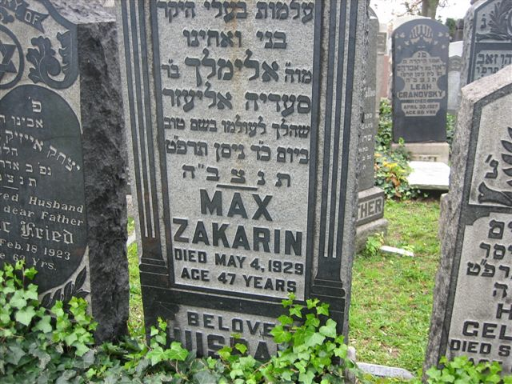
Gravestone of Max Zakarin
Hebrew inscription:
"Here is buried our dear husband, son, and brother
Our teacher, Rabbi Elimelekh
Son of the Rabbi Saadya Eliezer
Who died on the 24th day of the month of Iyar, year 5689."

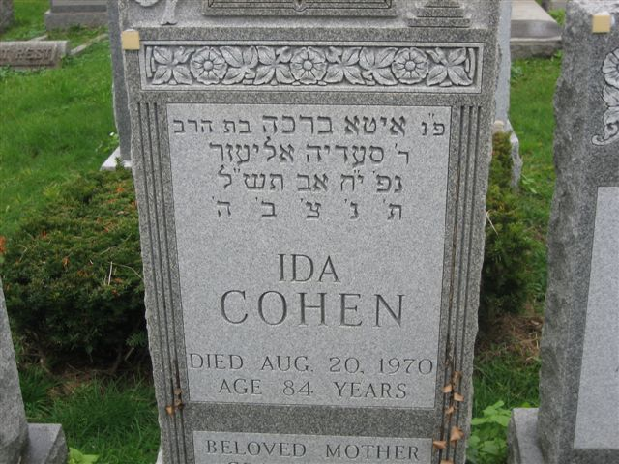

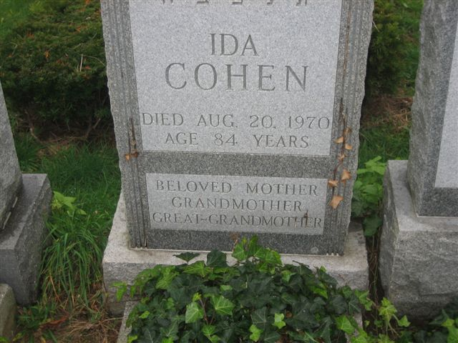
Gravestone of Ida Cohen
Hebrew inscription:
"Here is buried Ita Brakha
Daughter of the Rabbi Reb Saadya Eliezer
Who died on the 18th day of the month of Av, year 5730."

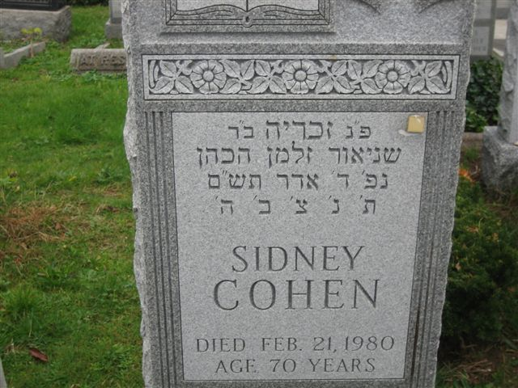
Gravestone of Sidney Cohen
Hebrew inscription:
"Here is buried Zacharia
Son of the Reb Schneur Zalman the Cohen
Who died on the 4th day of the month of Adar, year 5740."

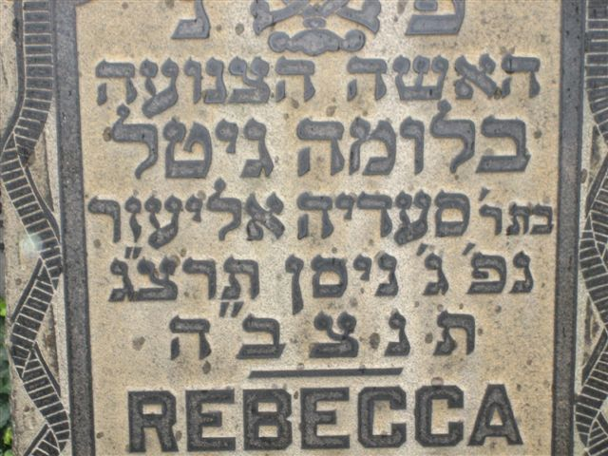

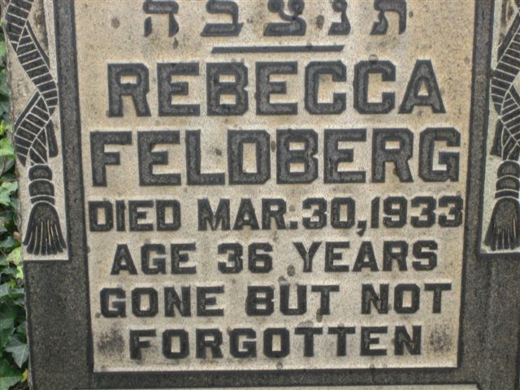
Gravestone of Beckie Feldberg
Hebrew inscription:
"Here is buried a modest woman Blume Gitel
Daughter of the Rabbi Reb Saadya Eliezer
Who died on the 3rd day of the month of Nisan, year 5693."

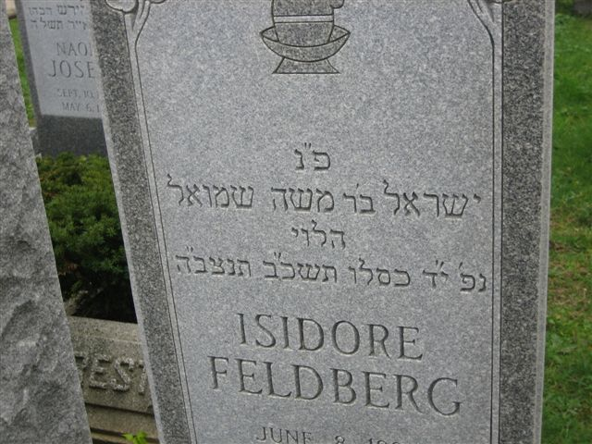

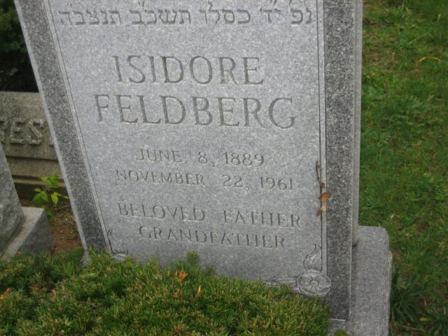
Gravestone of Isidore Feldberg
Hebrew inscription:
"Here is buried Israel
Son of the Reb Moshe Shmuel the Levi
Who died on the 14th day of the month of Kislev, year 5722."

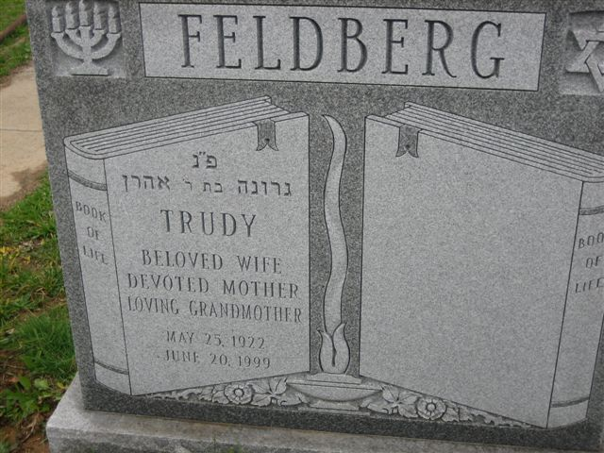
Gravestone of Trudy Feldberg
Hebrew inscription:
"Here is buried Gruneh
Daughter of Reb Aaron"

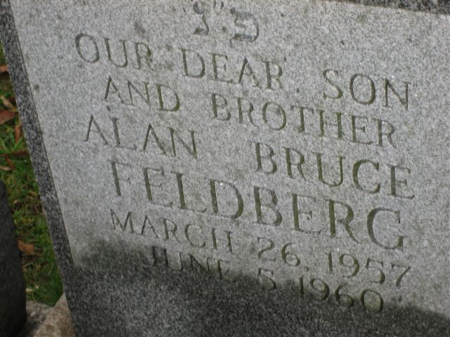
Gravestone of Alan Feldberg, son of Sammy Feldberg, who died at the age of 3

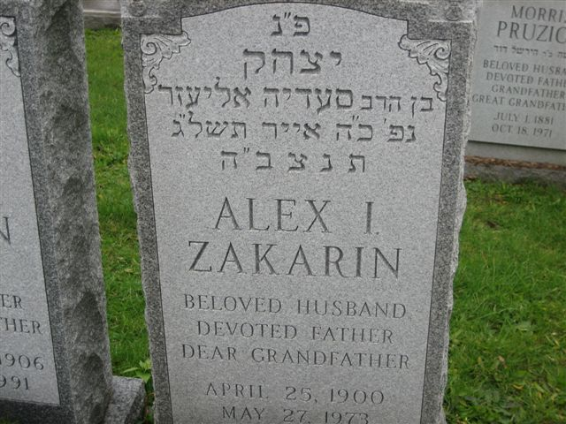
Gravestone of Alex Zakarin
Hebrew inscription:
"Here is buried Itzhak
Son of the Rabbi Saadya Eliezer
Who died on the 25th day of the month of Iyar, year 5733."

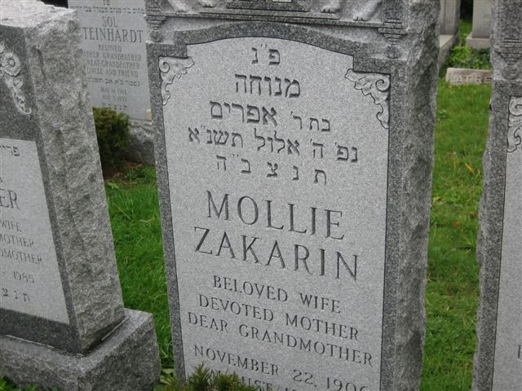
Gravestone of Mollie Zakarin
Hebrew inscription:
"Here is buried Menukha
Daughter of Reb Efraim
Who died on the 5th day of the month of Iyar, year 5751."
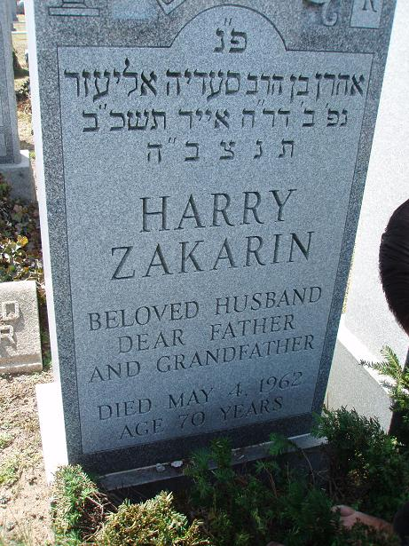
Gravestone of Harry Zakarin
Hebrew inscription:
"Here is buried Aaron
Son of the Rabbi Saadya Eliezer
Who died on the 2nd day of the month of Iyar, year 5722."

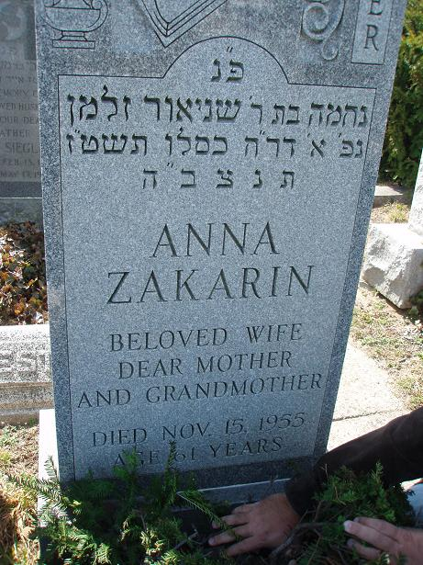
Gravestone of Anna Zakarin
Hebrew inscription:
"Here is buried Nechama
Daughter of Reb Schneur Zalman
Who died on the 1st day of the month of Kislev, year 5716."

