Esther Zakarin

Esther Menucha Zakarin was a strong-willed woman who arrived with her husband, Samuel, in the United States in 1906, settling together with her children and grandchildren in Brooklyn. Short in stature but long on determination, she played the role of the influential matriarch of a large and expanding family.

Background

Esther was born circa 1861 in Tsarist Russia. According to the text on her gravesite, her father's name was Avigdor.

Esther's exact family name is unknown, but a hint is provided by her grandson, Murray Feldberg, who recently located his mother Beckie's death certificate, and generously agreed to share it with this forum. The certificate can be viewed in the Original Documents page of this web site.

Note that the form, which contains a space for the mother's maiden name, was completed by a city clerk, who used a highly improbable spelling, Malkloff. "I recall hearing the name pronounced MAL-kee-off," said Murray.

Emigration

It appears that the Zakarins had to leave Russia quickly. According to great-granddaughter Judy Zakarin Averick, Esther, driving a covered wagon, succeeded in kidnapping one of her own sons from the Tsar's army and from the compulsory 25-year service that it entailed, and smuggled him out of the country.

Which child could this have been? Perhaps it was Max - who was approximately 24 years old in 1906 - and one of the first family members to leave Russia. However, since the Russians were also known to draft Jewish children as young as 12 into military schools, it is also realistic that sixteen-year-old Isidor and fourteen-year-old Harry were candidates for conscription.

Home and Business

Esther & Samuel had a large house at 506 Hendrix Street (near the corner of Sutter Street) in the East New York section of Brooklyn. She converted their spacious porch into a windowed storefront, where a big sign informed passers-by, We Sell Religious Articles. According to Belle Feldberg Hecht, A tallith hung from a wooden window shutter. "I used to help her by stocking the store with books," said Murray Feldberg. "I would travel to the well-known printer, Hebrew Publishing, on Delancey Street in Manhattan, and return with Bibles and prayer books to be sold in the store."

Behind the storefront, there was a large area for guests. Two rooms, a living room and a dining room, were separated by sliding doors that when opened, formed a huge banquet hall that filled up with family members on Friday nights. "My grandmother was a great cook, and all the guests would contribute a dish to the meal," said Murray.

During this period, the East New York section of Brooklyn, then an outlying suburb of New York City, was rapidly becoming urbanized. Despite this, according to Judy Zakarin Averick, the Zakarin family's yard was deemed a suitable place to keep chickens to be used in the traditional expiation rite prior to Yom Kippur. Eventually, the City of New York passed new regulations forbidding the raising of farm animals in the area. Esther, a fighter by nature, took the authorities to task, battling city clerks and lawyers. The chickens remained.

Out and About

Esther's everyday attire included a gold chain with a watch hanging from it.

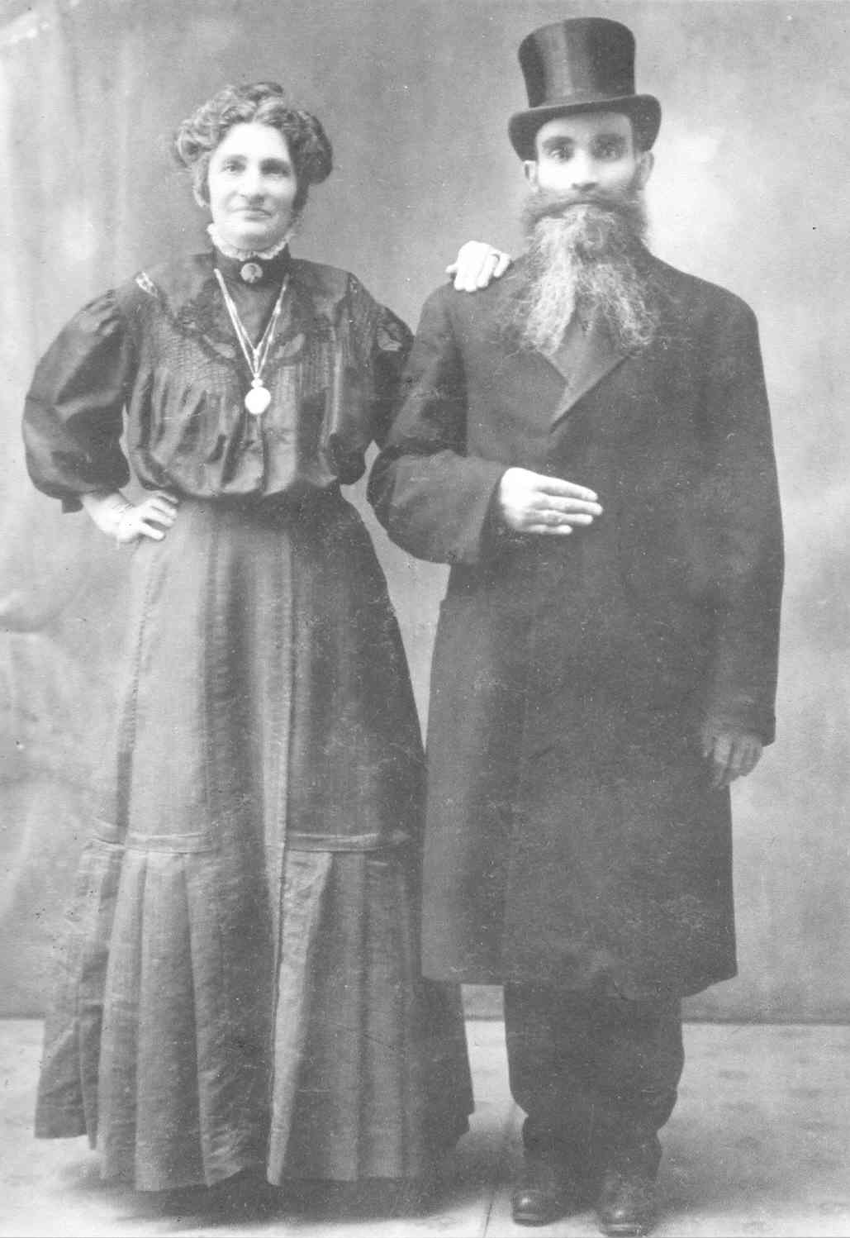
Esther and Samuel Zakarin
Photo Courtesy of Murray Feldberg

Esther was very adamant about preserving Yiddish as her daily language, and encouraged her family to do the same, said granddaughter Belle Feldberg Hecht. When questioned about her preference, she would reply, "Ich bin nicht a Yankee."

"When my mother and Bubbe would visit me at school, I would greet them in Yiddish, and then introduce them to my teacher in English," explained Belle. In this way, I was forced to be fluent in both English and Yiddish.

Esther and family would regularly attend the neighborhood cinema – the Miller Theater, on Sutter Street between Miller and Bradford streets. Films attended on the Sabbath would be paid for in advance. Thrift also played a central role at the movie house. Once a week, on "Dish Night", the theater held a promotion, offering a free plate to each paying customer. The Zakarins would attend en masse, instantly accumulating a "set" of plates. According to great-grandson Mort Zakarin, these dishes were made of colored glass – known today as Depression Glass – and have become valued collector's items.

Discipline

"Esther was a dominant woman who had the last word on everything," recalled great-grandson, Norman Zakarin. "Especially when it came to living arrangements – everyone had to live close by."

"I was actually quite afraid of her," said granddaughter Renee Cohen Silverman. "When I saw her coming for a visit, I would quickly go outside to play with the other children."

"Even though she spoke English very well, she insisted that I speak to her in Yiddish. She would ask me the same question over and over until I answered her correctly."

Esther was a religious woman who attended the Chevra Mishnaias synagogue a few blocks away on Hendrix Street. According to Norman Zakarin, she would sit upstairs in the women's section, "and all of us would go to greet her before taking our own seats. Anyone who didn't come to say hello would get an earful later on."

Granddaughter Marilyn Zakarin Belous recalled a similar experience: "I grew up in the same two-story house at 506 Hendrix Street where Bubbe lived. My parents, Abe and Marcia, and my sisters and I lived on the second floor, while Bubbe lived on the ground-floor apartment with Louis and his family. When my father would come home in the evening, he would always stop to visit Bubbe before joining us upstairs."

"My mother, Marcia, had her hands full raising four girls. One day, Bubbe came upstairs to ask for some coffee. My mother, who was busy feeding one of her baby daughters, asked her if she could wait a moment. Esther, visibly infuriated, quickly left without a word, slamming the door shut on her way downstairs."

A Quick Pair of Hands

Esther believed in maintaining a tight family circle, and spent considerable effort in trying to keep all of her children and grandchildren close at hand. Esther wanted to be able to walk on foot to the home of any member of the family, according to Murray Feldberg.

Breaches in family discipline invited swift retribution from Esther, explained great-grandson Mort Zakarin: "My father, Charlie, a man who never really succeeded in any business or profession, received an exciting offer – to be a partner in a large and successful auto parts wholesaler. It was a golden opportunity – the company already had an excellent reputation, and would in time become the market leader in the region."

"There was just one problem, though. The new job would require relocation to Glen Cove on Long Island – not exactly walking distance. One day, my parents took my brother Irving and myself for a visit there. It was a long drive from Brooklyn in those days – 4 or 5 hours over bumpy farm roads."

"Anyway, when Esther got wind of the developments, she approached Charlie, and greeted him with a slap in the face."

"We stayed in Brooklyn."

Apparently, Esther didn't need such extreme reasons to impose such handy discipline on family members, explained Murray Feldberg. "My mother, Beckie Zakarin Feldberg, always encouraged me to be of assistance to family members. She was always sending me to help this or that uncle who was peddling something in the street. I often went to help my grandmother, too. One day, when I was about ten years old, I was changing a pillowcase in a way that wasn't to her liking. She came over and let me have it – right in the kisser. After that, I made sure to do it her way."

Soft Spot

Did Esther have a "soft spot" for anyone?

"Yes, she did - for my mother," explained Murray Feldberg. "My mother Beckie was her youngest daughter, and the apple of her eye."

"Bubbe lived together with us during her last years and spoiled me rotten," claimed grandson Stanley Zakarin. "When I misbehaved, and my father, Louis, would try to punish me, she would interfere. Shlug mir ('Hit me instead'), she would tell him."

Many thanks to the following family members for their contributions:
- Judy Zakarin Averick
- Marilyn Zakarin Belous
- Murray Feldberg
- Belle Feldberg Hecht
- Renee Cohen Silverman
- Mort Zakarin
- Norman Zakarin
- Stanley Zakarin

Narration: Yosi (Jeff) Zakarin
Revised: August 2008

